**SQL Assignment: All concepts II**

*\*\*Same database file from previous assignment will be used in this assignment. If you haven’t download the first assignment yet follow the instructions:*

**Download the following database file from the link:**

**AirlineDB**: https://drive.google.com/file/d/15ehp3FtyuYqExne3FaFcWHB4TFI_vtSR/view?usp=sharing

**Table structure**

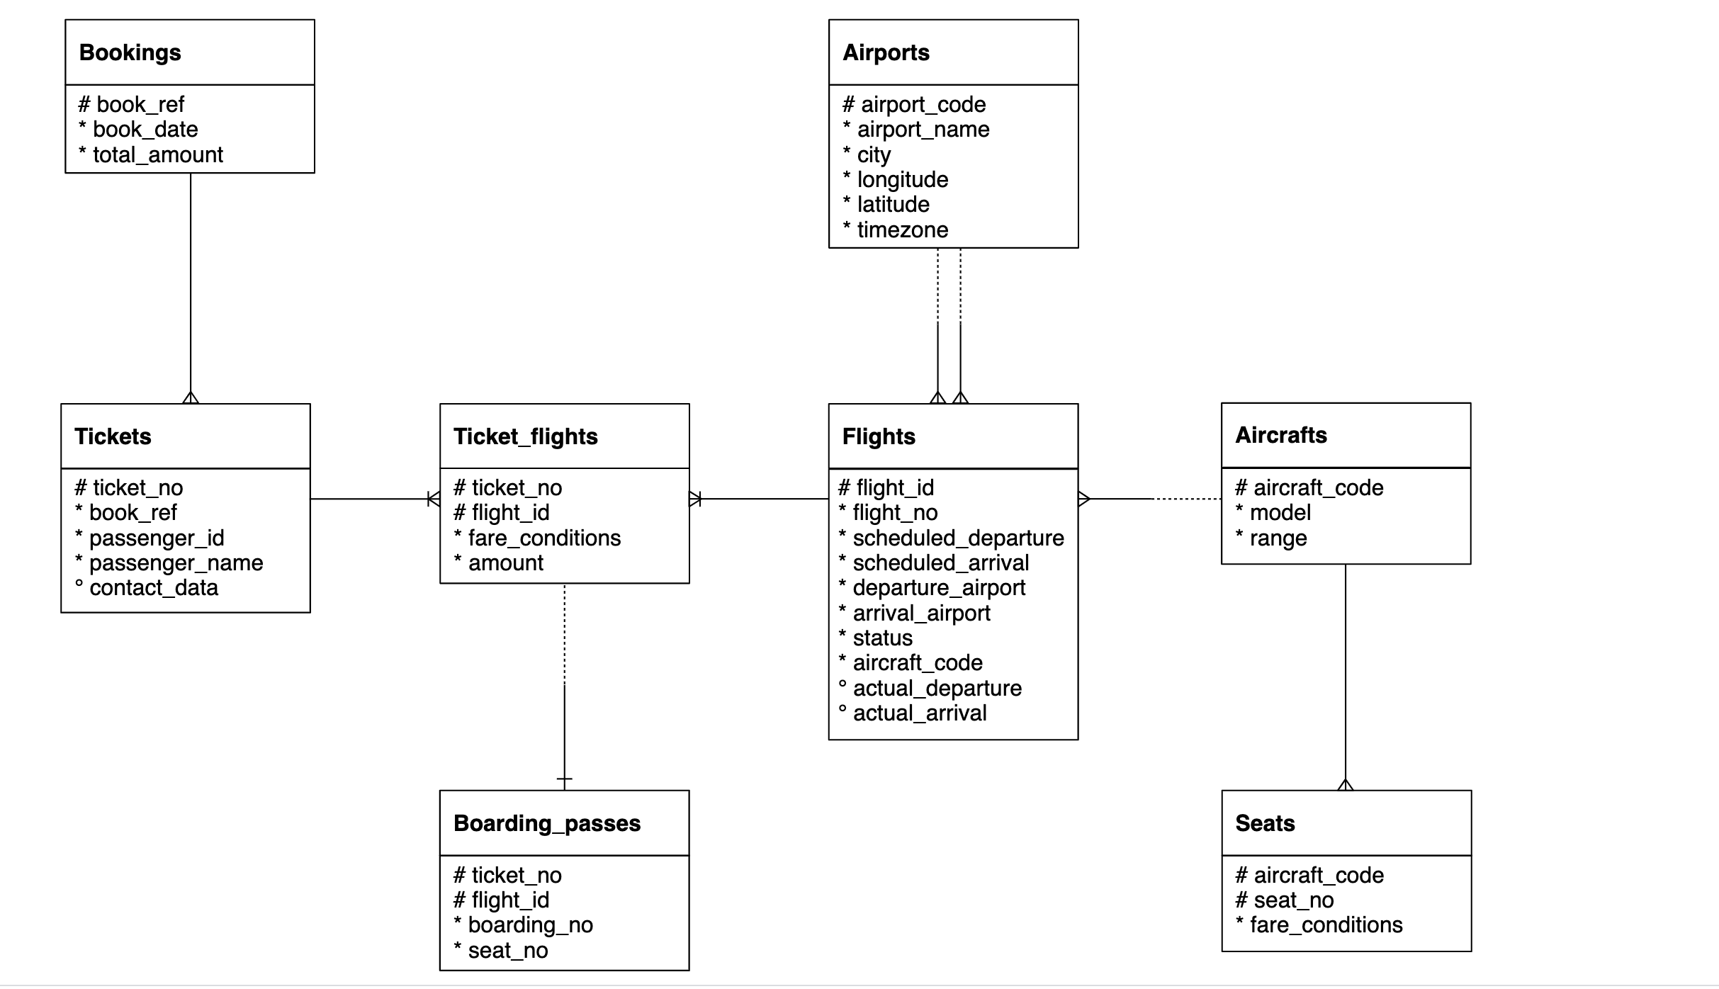

Important Instructions:

* Download the database link and restore in postgres. For restoration, you can refer to the instructions in the first chapter of SQL
* The AirlineDB is quite big in size, hence restoration might take time. Once the restoration starts, wait for 15 to 20 mins and don’t shut down the computer
* Table names in database has “**booking.”** as prefix. For example, bookings.tickets, bookings.boarding_passes. Hence use the prefix in the query as well
  + Correct way of accessing tables: SELECT * FROM **bookings.tickets**
  + Wrong way of accessing tables: SELECT * FROM tickets
* Queries need to be submitted in a **word/text file**. CSV output of the queries will **NOT** be accepted
* Expected output written is written in some of the following question to make sure that you are getting the columns in the same sequence. It doesn’t mean that you will get same values in the output. The exact values in your queries might be different depending on the values sorted in your copy of database.

1. Find list of airport codes in Europe/Moscow timezone

Ans:

Select

Airport_code

From bookings.Airports

Where timezone = 'Europe/Moscow'

1. Write a query to get the count of seats in various fare condition for every aircraft code?

Ans :

Select

Fare_conditions,Count (seat_no)

From bookings.seats

Group by Fare_conditions

1. How many aircrafts codes have at least one Business class seats?

Ans :

Select

Distinct A.Aircraft_code,S.Fare_conditions

From bookings.Aircrafts A

Inner join bookings.Seats S

On A.Aircraft_code = S.Aircraft_code

Where S.fare_conditions = 'Business'

1. Find out the name of the airport having maximum number of departure flight

Ans:

Select departure_airport, Count(Scheduled_departure) DEPCOUNT

From bookings.Flights

Group by departure_airport

Order by 2 desc

1. Find out the name of the airport having least number of scheduled departure flights

Ans:

Select departure_airport, Count(Scheduled_departure) DEPCOUNT

From bookings.Flights

Group by departure_airport

Order by 2 Asc

1. How many flights from ‘DME’ airport don’t have actual departure?

Ans : Select departure_airport, Count(Scheduled_departure ) - Count (actual_departure) Can_dep

From bookings.Flights

Where departure_airport = 'DME'

Group by 1

1. Identify flight ids having range between 3000 to 6000

Ans: Select F.Flight_id,A.Range

From bookings.flights F

Inner join bookings.Aircrafts A

On F.Aircraft_code = A.Aircraft_code

Where A.Range between 3000 and 6000

Order by 2

1. Write a query to get the count of flights flying between URS and KUF?

Ans : Select

Count(Flight_id)

From bookings.flights

Where Departure_Airport in ('URS','KUF')

And Arrival_Airport in ('URS','KUF')

1. Write a query to get the count of flights flying from either from NOZ or KRR?

Ans:

Select

Count(Flight_id)

From bookings.flights

Where Departure_Airport = 'NOZ' or Departure_Airport = 'KRR'

1. Write a query to get the count of flights flying from KZN, DME, NBC,NJC,GDX,SGC,VKO,ROV

Ans:

Select

Count(Flight_id)

From bookings.flights

Where Departure_Airport In ('KZN', 'DME', 'NBC','NJC','GDX','SGC','VKO','ROV')

1. Write a query to extract flight details having range between 3000 and 6000 and flying from DME

Ans :

Select *

From bookings.flights F

Inner join bookings.Aircrafts A

On F.Aircraft_code = A.Aircraft_code

Where A.Range between 3000 and 6000 and Departure_Airport = 'DME'

1. Find the list of flight ids which are using aircrafts from “Airbus” company and got cancelled or delayed

Ans:

Select Flight_id,Status,Model ->> 'en' as keyEn

From bookings.Flights F

Inner join bookings.Aircrafts_data A

on F.Aircraft_code = A.Aircraft_code

Where Model ->> 'en' like 'Airbus%'

And Status in ('Cancelled','Delayed')

1. Find the list of flight ids which are using aircrafts from “Boeing” company and got cancelled or delayed

Ans:

Select Flight_id,Status,Model ->> 'en' as keyEn

From bookings.Flights F

Inner join bookings.Aircrafts_data A

on F.Aircraft_code = A.Aircraft_code

Where Model ->> 'en' like 'Boeing%'

And Status in ('Cancelled','Delayed')

1. Which airport(name) has most cancelled flights (arriving)?

Ans:

Select Count (Departure_Airport),Departure_Airport,Status,Actual_arrival

From bookings.Flights F

Where Status in ('Cancelled')

And Actual_arrival is null

Group by 2,3,4

Order by 1 desc

limit 1

1. Identify flight ids which are using “Airbus aircrafts”

Ans :

Select Flight_id,Model ->> 'en' as keyEn

From bookings.Flights F

Inner join bookings.Aircrafts_data A

on F.Aircraft_code = A.Aircraft_code

Where Model ->> 'en' like 'Airbus%'

1. Identify date-wise last flight id flying from every airport?

Ans:

Select Flight_id,departure_Airport,Date1 ,Time1,

Rank() over (Partition by departure_Airport order by date1) rankedA,

Rank() over (Partition by date1 order by Time1 desc) rankedD

From (Select Flight_id,departure_Airport,

Cast (Scheduled_departure as Date)Date1,

Cast (Scheduled_departure as Time) Time1

from bookings.flights)A

1. Identify list of customers who will get the refund due to cancellation of the flights?

Ans:

Select Passenger_id,Passenger_name,TF.Ticket_no,TF.flight_id,TF.Amount,F.Status

FROM bookings.tickets T

Inner Join bookings.Ticket_Flights TF

On T.Ticket_no = TF.Ticket_no

Inner Join Bookings.Flights F

On TF.Flight_id = F.Flight_id

Where Status = 'cancelled'

1. And how much amount they will get?

Ans :

Select Passenger_id,Passenger_name,Sum(Amount),F.Status

FROM bookings.tickets T

Inner Join bookings.Ticket_Flights TF

On T.Ticket_no = TF.Ticket_no

Inner Join Bookings.Flights F

On TF.Flight_id = F.Flight_id

Where Status = 'Cancelled'

Group by 1,2,4

1. Identify date wise first cancelled flight id flying for every airport?

Ans:

Select Flight_id,departure_Airport,Status,Date1 ,Time1,

Rank() over (Partition by departure_Airport order by date1) rankedA,

Rank() over (Partition by date1 order by Time1) rankedD

From (Select Flight_id,departure_Airport,Status,

Cast (Scheduled_departure as Date)Date1,

Cast (Scheduled_departure as Time) Time1

from bookings.flights

Where Status = 'Cancelled')A

1. Identify list of Airbus flight ids which got cancelled.

Ans:

Select Flight_id,Status,Model ->> 'en' as keyEn

From bookings.Flights F

Inner join bookings.Aircrafts_data A

on F.Aircraft_code = A.Aircraft_code

Where Model ->> 'en' like 'Airbus%'

And Status in ('Cancelled')

1. Identify list of flight ids having highest range.

Ans :

Select F.Flight_id,A.Range

From bookings.Flights F

Inner join bookings.Aircrafts A

On F.Aircraft_code = A.Aircraft_code

Order By 2 desc